

Judith (Judie) List Sweeney –2014

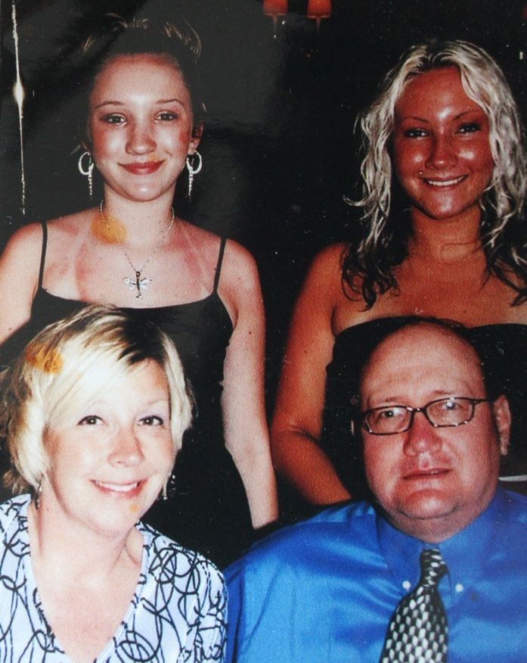

(l-r) Back Row: Alina and Lyndsay Williams

Front Row: Marilyn List Williams and Patrick Williams – about 2007 (est.)